CONSTRAINTS

Constraints are used to:

- Define the primary key for the table.

  - Implemented via the definition of the primary key constraint.

- Define relationships between tables.

  - Implemented via the definition of the foreign key constraint.

- Define a default value for a column. This default value can be used when new rows are inserted (added) into a table.

  - Implemented via the definition of the default constraint.

- Define a domain of valid values that a column can assume.

  - Implemented via the definition of the check constraint.

- Ensure that all values in a column are unique.

Constraints can be defined:

- When the table is initially created, as part of the CREATE TABLE statement or,
- For an existing table, via the ALTER TABLE statement.

We use the CONSTRAINT keyword to define a constraint. A single column can have multiple constraints, each with its own constraint keyword definition. Each constraint must have a unique name. The constraint name is used in SQL messages, so use descriptive constraint names. We will use a prefix, as part of the constraint name, to identify the type of constraint:

Prefix | Constraint Type
PK | Primary key
FK | Foreign key
CK | Check
DF | Default

A constraint can be defined as a column level constraint (applies to one column only) or as a table level constraint (applies to many columns in the table). Constraints are not enforced in the same batch that they are defined in so DO NOT insert, update or delete data from a table in the same batch that defines a constraint.

Primary Key Constraint

When using a normalized database design, all tables must have a primary key constraint. Any column that acts as a primary key must be defined as a not null column. The DBMS will ensure that all rows in the table have a unique value for primary key columns.

When a primary key constraint is defined SQL Server will automatically create a clustered index for the column(s) acting as the primary key. An index is an object, which is stored in the database. Functionally, an index is similar to the index found at the back of a book. The index in a book lets you find a specific topic in the book quickly. An index object contains information that SQL Server uses to quickly find a specific row in the table. Indexes can speed up the retrieval of data from the database. However, indexes can worsen the performance of programs that insert/update/delete data in the database. If you insert a row into a table that has three indexes associated with it, SQL Server has to add four rows to the database: one to the target table and one to each of the indexes. We will discuss indexes again in a later lesson.

Syntax

[CONSTRAINT constraint name ]
PRIMARY KEY [ CLUSTERED | NONCLUSTERED ]
( col_name [ , col_name2 [ . . . col_name16 ] ] )

Example:

To define the StudentId column as a primary key in the Student table:

CREATE TABLE Student (

StudentId char(9) not null
Constraint PK_Student primary key clustered,
LastName varchar(20) not null,
FirstName varchar(15) not null,
)

This example demonstrates a column level primary key constraint definition.

A table level primary key constraint is used when the table has a composite key (multiple columns acting as the primary key).

Example:

To define the StudentId and CourseId columns as the primary key for the Marks table:

CREATE TABLE Marks (

StudentId char(9) not null,
CourseId char(6) not null,
Mark smallint null,

Constraint PK_Marks primary key clustered
(StudentId, CourseId)
)

Exercise

Modify the script that defines the Employee, Project and EmployeeOnProject tables to include the necessary primary key constraint definitions.

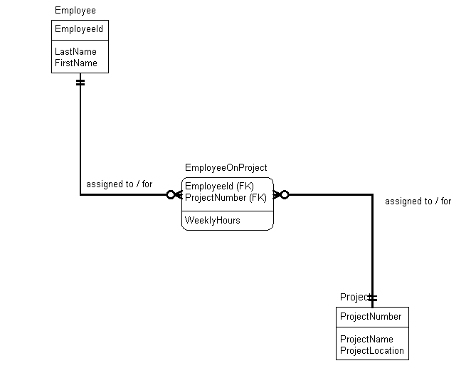

Use the sp_help procedure to retrieve a description of the tables from the database. If you display the output in grid it is easier to view. The information on indexes for a table is displayed in the 6th grid. The information on constraints is displayed in the 7th grid.

Save this script file as it will be used again for exercises in future lessons.

Foreign Key Constraint

The foreign key constraint defines a relationship between rows (usually in different tables). In addition, the foreign key constraint defines a parent-child relationship between the tables involved. The table with the foreign key acts as the child table in the relationship. The table with the associated primary key acts as the parent table in the relationship. Consider the following tables for a chain of stores that operates internationally.

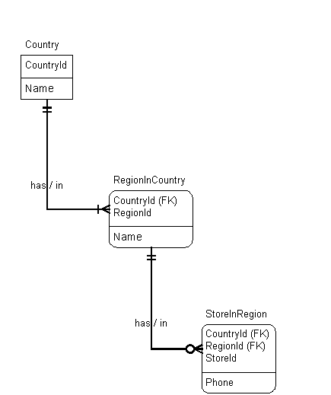

CountryId and StoreId are unique. RegionId is unique within Country (the first region in any country is region 1).

In the RegionInCountry table (child) the foreign key, CountryId, relates rows to the parent table, Country. A column level foreign key constraint, for the CountryId column in the RegionInCountry table, implements this relationship.

In the StoreInRegion table (child) the foreign key, CountryId and RegionId, relates rows to the parent table, RegionInCountry. A table level foreign key constraint, CountryId and RegionId columns, in the StoreInRegion table, implements this relationship.

The foreign key constraint defines referential integrity between two tables. Operations that affect the tables and or the data stored within the tables must comply with referential integrity. This affects:

- Dropping tables.
- Creating tables.
- Inserting/Updating/Deleting rows in tables.

The bottom line for referential integrity is that a child row/table cannot exist without its associated parent row/table. Therefore:

- You must Drop a child table BEFORE you Drop the associated parent table.
- You must Create a parent table BEFORE you Create the associated child table.
- The value of a column acting as a foreign key must be:

  - A value that exists as a primary key in the associated parent table, or
  - NULL

If we were to create a script file to drop the existing definition of the Store tables and recreate them we would sequence the commands in the following order:

Drop Table StoreInRegion
Drop Table RegionInCountry
Drop Table Country

Create Table Country ( . . .
Create Table RegionInCountry( . . .
Create Table StoreInRegion( . . .

A column acting as a foreign key can be defined as a NULL or as a NOT NULL column and must have the same datatype as its associated primary key. The DBMS will NOT automatically create an index for a foreign key.

syntax:

[CONSTRAINT constraint name ]
[ FOREIGN KEY ( col_name [, . . . col_name16 ] ]
REFERENCES table_name ( ref_col [, . . . ref_col16] )

- col_name identifies the column(s) acting as the foreign key
- table_name identifies the parent table
- ref_col identifies the primary key in the associated parent table

Example:

To define the foreign key constraint for the RegionInCountry table:

CREATE TABLE RegionInCountry (

CountryId smallint not null
Constraint FK_RegionInCountryToCountry
references Country (CountryId),
RegionId smallint not null,
Name varchar(100) not null,

Constraint PK_CountryId_RegionId
Primary key clustered (CountryId, RegionId)
)

This demonstrates the use of a column level foreign key constraint. Note that a single column (e.g. CountryId) can act as both a primary key and a foreign key.

Example:

To define the foreign key constraint for the Store In Region table:

CREATE TABLE StoreInRegion (

CountryId smallint not null,
RegionId smallint not null,
StoreId smallint not null,
Phone varchar(100) not null,

Constraint PK_CountryId_RegionId_StoreId
Primary key clustered (CountryId, RegionId, StoreId),

Constraint FK_StoreInRegionToRegionInCountry
Foreign Key (CountryId, RegionId)
References RegionInCountry (CountryId, RegionId)
)

This demonstrates the use of a table level foreign key constraint. The foreign key constraint applies to two columns, hence the use of the table level constraint.
Exercise

Modify the script that defines the Employee, Project and EmploeeOnProject tables to include the necessary foreign key constraint definitions.

Create the Department table as a stand-alone table for now (no relationships to other tables). Use the identity property for the Department Number.

